KB0055163
Creating a Self Service incident ticket by end users for Finance Technology COE | Tax Technology supported Apps
Intended Audience:
All

For Finance Technology COE | Tax Technology supported Apps, end users shall use the process outlined below to submit a ticket.
STEP 1
Navigate to UTC’s Next Connect Portal: https://home.rtx.com/es-get-help

STEP 2
- Click Tax Technology
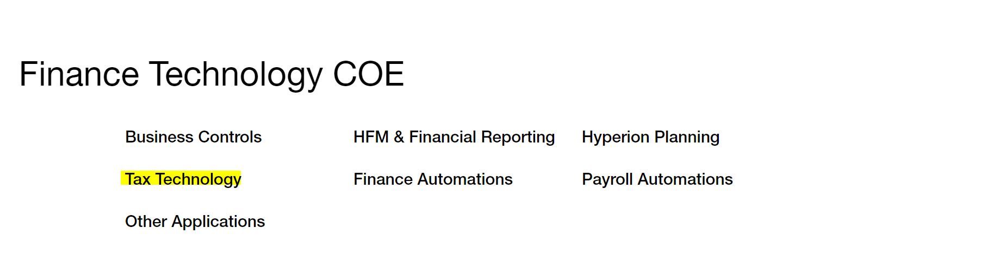
The default Service is
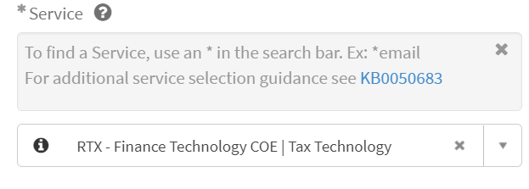
Tip: to find the right *Service/Application Impacted category, you can search by key words, such as below

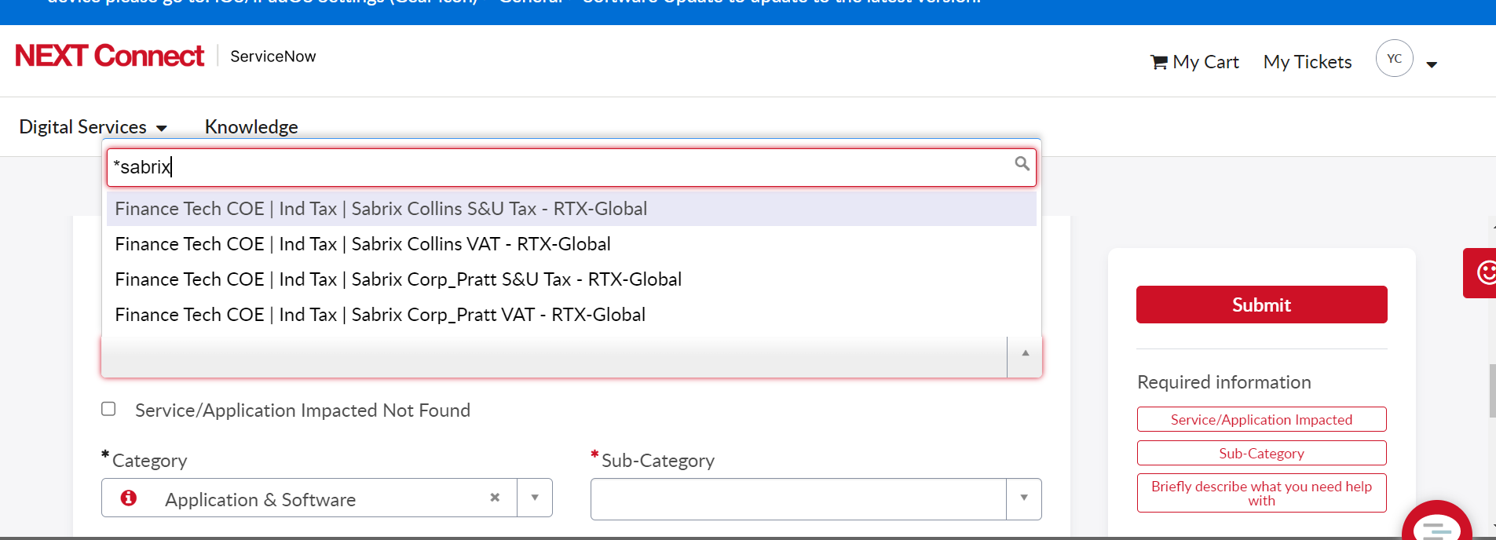
STEP 3
On the help desk form, fill in the “Callback Phone Number”, “Sub-Category” and “Briefly describe what you need help with” fields (you can also use the “Provide additional details” field). All other fields will be pre-populated. DO NOT CHANGE THE PREPOPULATED FIELDS. The prepopulated fields ensure that the help desk ticket will immediately route to the Finance Technology COE.
- Choose Sabrix/OneSource Sales and Use Tax from the following Application Service:
  - Corptax
  - CertCapture
  - Longview Tax Data Repository
  - Longview Tax Provision
  - Project Online for Tax Planning
  - Property Tax Mgt System (PTMS)
  - R&D Credit System
  - Sabrix/Onesource Sales & Use Tax
  - Sabrix/Onesource VAT
  - Tax Audit defense tool
  - Tax SharePoint
  - Tax Work Order System
  - Vertex Sales & Use Tax
  - Vertex VAT
- Choose an applicable Situation from the list of values
- Briefly describe your issue (Summary)
- Add more details in the “Provide additional details” space
- You may also provide additional details and context by attaching a document
In the “Briefly describe what you need help with” field, put the name of the application you need help with first (e.g..), and then describe the issue (see example in screen shot below). This will enable us to quickly assign the help ticket to the appropriate analyst. You may also provide additional details and context by attaching a document.
STEP 4
- Click Submit.
  - A ticket is created and the user shall receive an email from ServiceNow to track its progress and updates

