How to Determine if Certificate is Validated in CertCapture

- Before contacting S&U Compliance Dept or raising a Tax Technology ticket perform the following steps to determine if the cert is in CertCapture and if it has been validated
- Open up CertCapture
- Use drop down and click on the legal entity
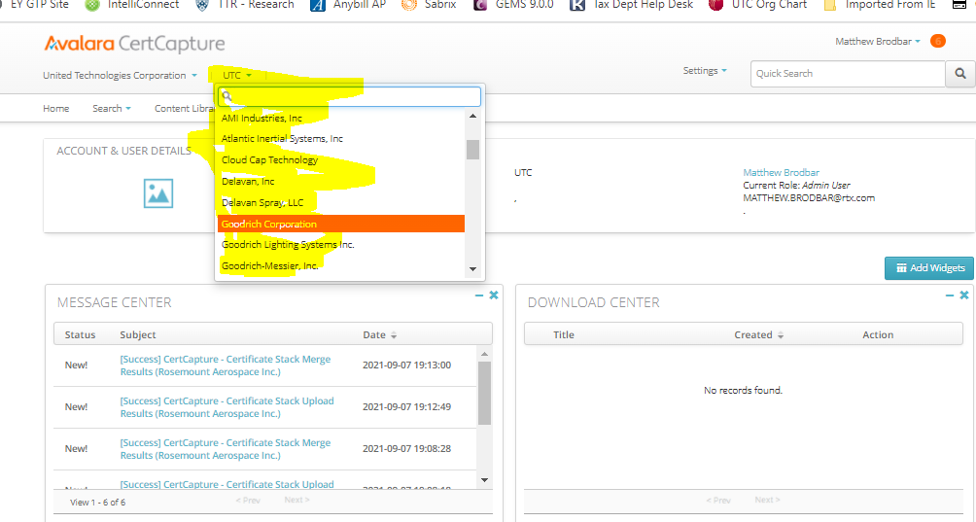
- Enter the customer number into the quick search field and press magnifying glass
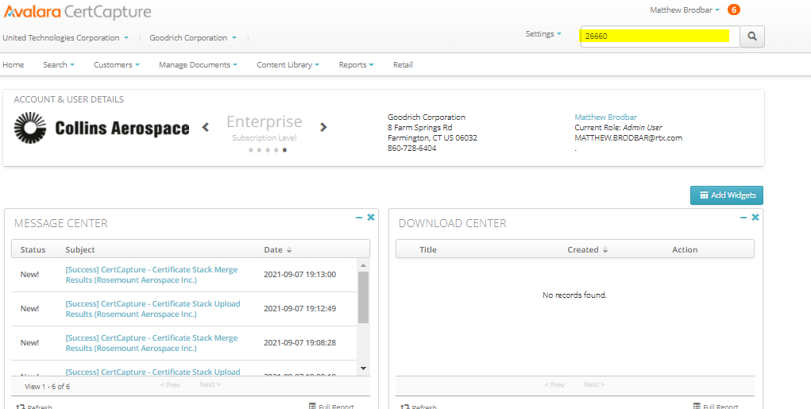
- Click on the BT customer #
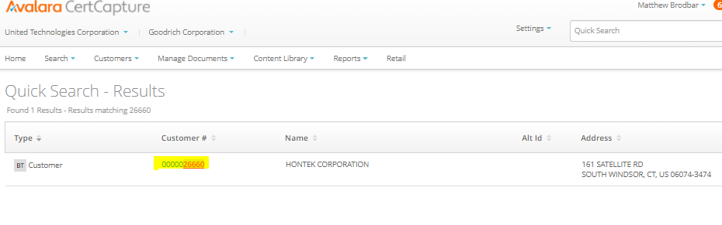

- Click on “Taxability Info”
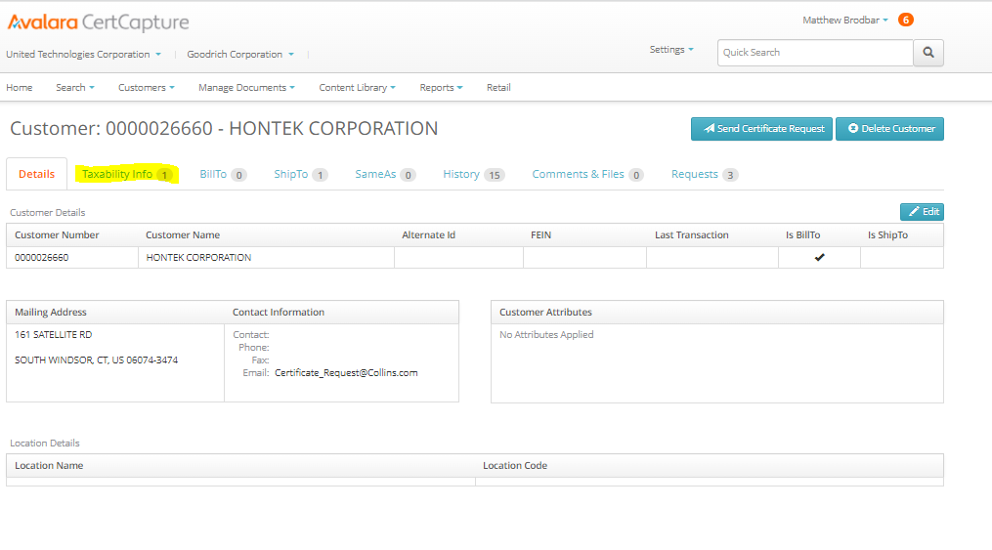
- Look for the state you are checking in the active linked certificates area and review the fields highlighted in yellow
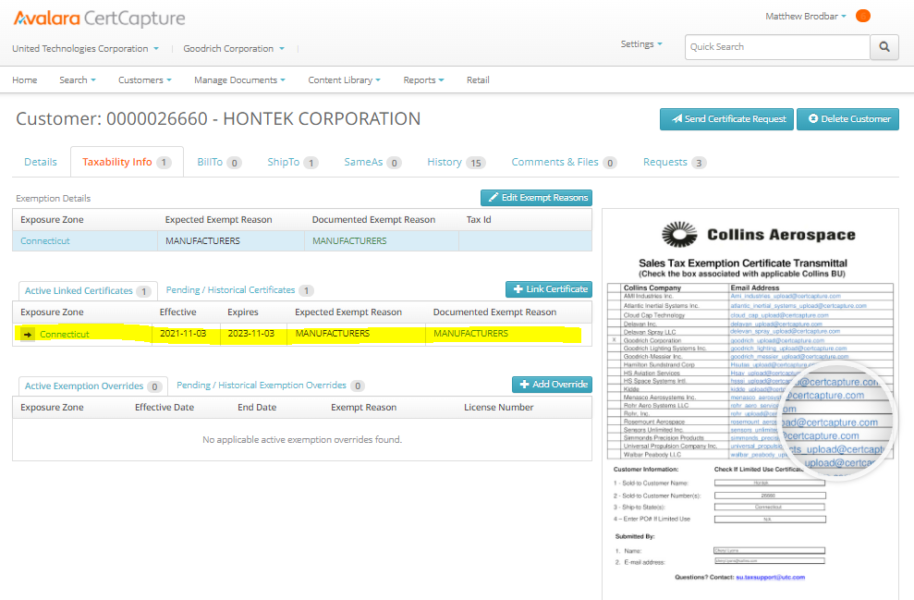

Actions based on Certificate Validation Review

- If state is not listed on this page then cert cannot be attached. Exposure zone needs to be set up
  - Contact master data team to update the partner ship to so it gets sent over to CertCapture
- Review the “Documented Exempt Reason” column
  - If it’s green that means it has been successfully validated with the specified reason
    - If transaction is calculating tax look at the effective date range
      - If transaction is outside effective date range
        - Email su.taxsupport@rtx.com to request back dating of effective range
      - If transaction is within effective date range
        - Raise a SNOW ticket to the Tax Technology Team to determine why transaction is taxable
        - https://unitedtechnologiescorporation.service-now.com/sp?id=sc_cat_item&sys_id=4e80312adbcbd3804cb24531ba961912&sysparm_user_bu=EAS&sysparm_user_bs=RTXFTCTT
        - In “Application Service” field chose Sabrix/Onesource sales & Use Tax
        - In “Situation” field, select Bug/Defect
        - Update last two fields with issue
  - If it’s red that means it is not validated because of the specified reason
    - If expired, missing, non-deliverable then BU needs to obtain cert and submit. Do not raise a ticket as there is nothing Tax Technology or Tax Compliance can do until a certificate is uploaded for validation
    - If certificate is invalid, determine reason by performing following steps
      - Click into active linked Cert
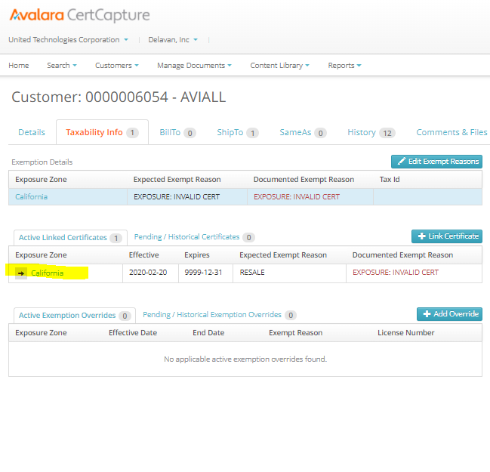
      - Click on “validation”
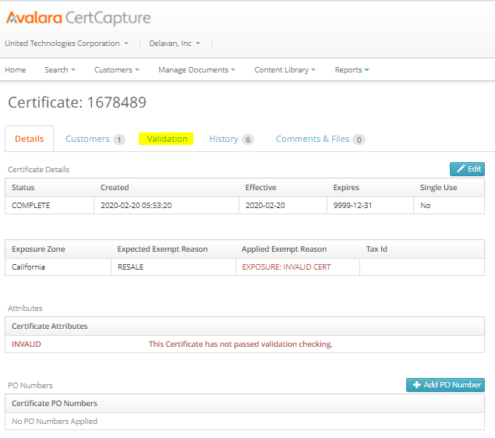
      - Note specified reason
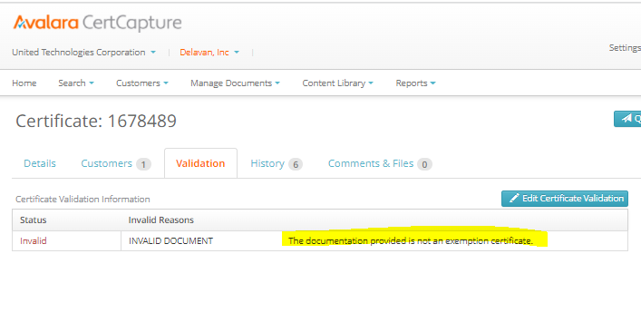
    - Follow up with customer to correct cert and then re-submit
    - If questions about the validation reason email su.taxsupport@rtx.com provide screenshot of reason along with copy of cert and transmittal sheet originally sent

Bill To Issue
- When uploading an exemption certificate in CertCapture, the Bill To flag must be present for the certificate to be sent to Onesource.
- To check if the Bill To flag is present follow these steps:
  - Log into CertCapture
  - Type in the business unit as well as the company code.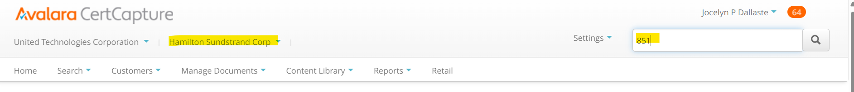
  - Select the correct customer. Note that the BT flag is seen on this page as well.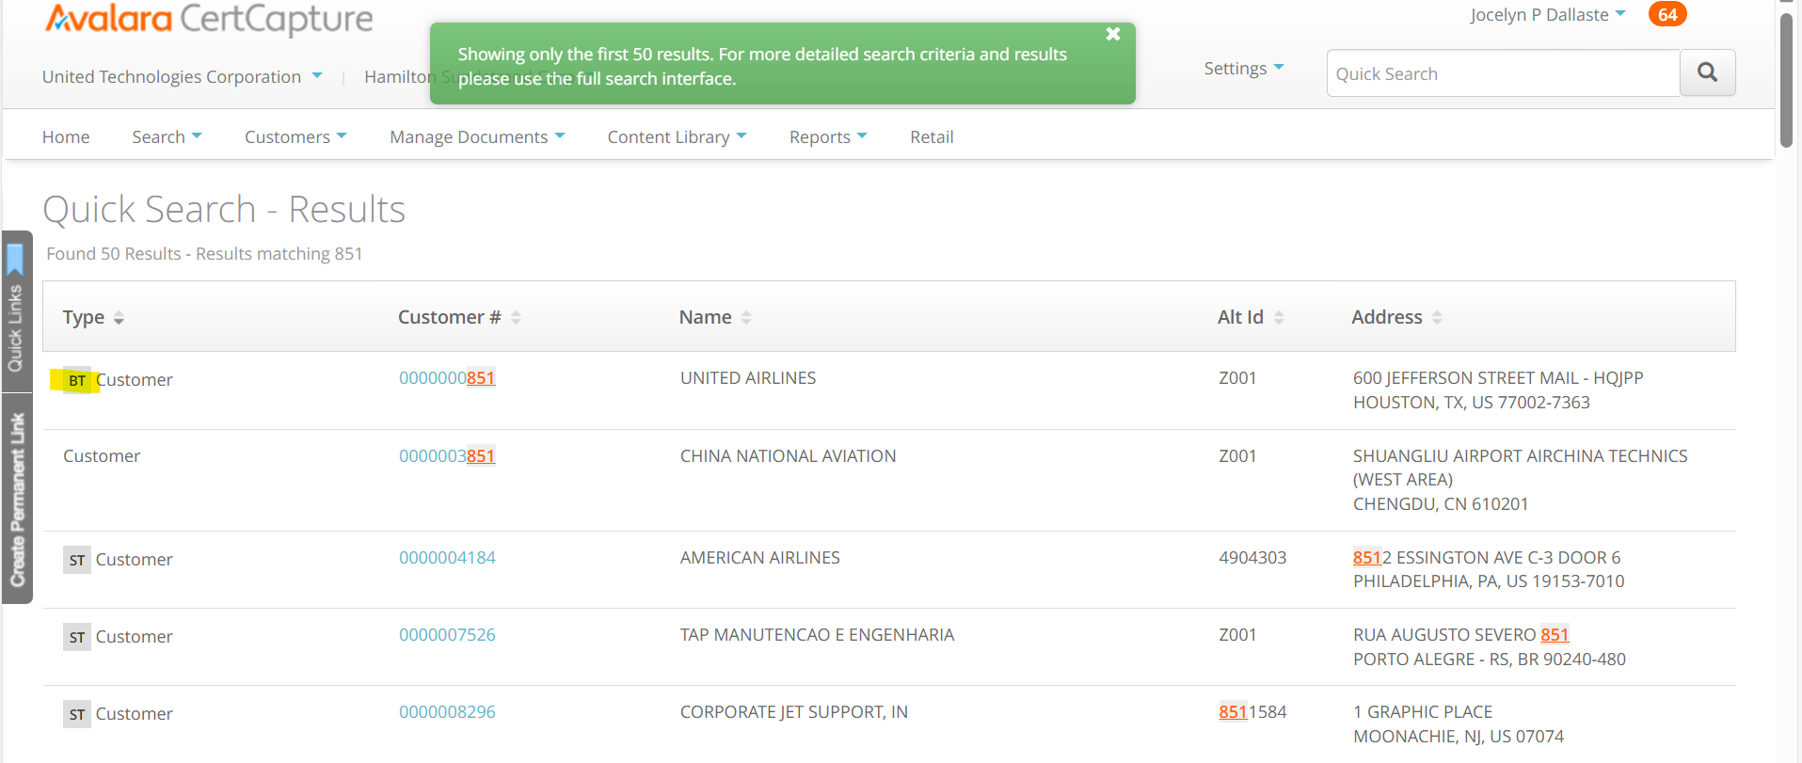
  - Go to the details tab where you will see if the Bill To section is checked off, meaning that the certificate has flowed through to Onesource. 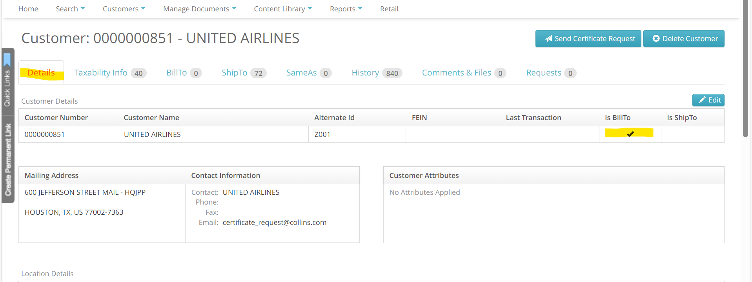

Resolution
- If there is no BT flag and you have confirmed it did not flow to Onesource, take these steps to obtain one:
  - Follow this link: Customer Master WF Menu - Collins Aerospace (utc.com) to fill out the Collins Aerospace SAP Customer Master Workflow Request Form. Please note you must be an authorized requestor. 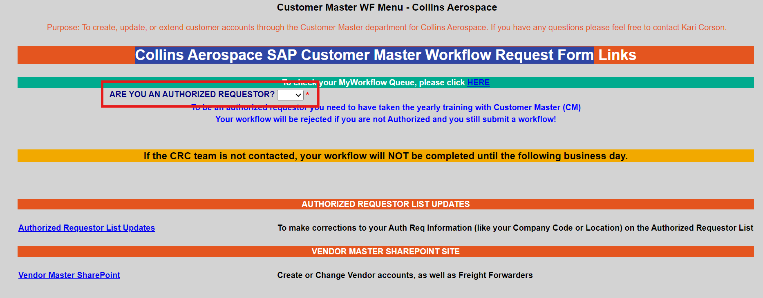
  - If further questions arise contact the Customer Master team, led by Kari.Corson@collins.com to help resolve your issue.

CertCapture Account Creation or Modification Request
Please complete the information below, attach it to the service now ticket and email it to the DT Tax Team:
Robert.Leeper@rtx.com and Ayaz.Lakhani2@rtx.com

Service Now Ticket Number:
(see below for help)
First Name:

Last Name:
(Surname)
Contact Number:
Location (Site):

Email Address:

Name of Direct Line Manager:

CertCapture Instance(s) For Access:  (See below for more details)
  ☐ Production
  ☐ Sandbox
Type of Request:
  ☐ New Access Request
  ☐ Modify Existing Access
Type of Access/ Role Required:  ‘Standard’ is default selection for business users  For other roles please contact Admins | Standard
Why the access in above Role needed?  Provide a brief description of user’s intended use.  “Need for my job” is not a valid reason and will be rejected. | Valid Example: Need to upload/validate certificates for (name of the company)
If user is a contractor, please enter the contract end date.
CertCapture Access End Date:
Company(ies) For Access:  Check which companies the user needs access:  ☒ Example Company Selection  Collins entities continue on next page
  Collins Entities
  ☐ AMI Industries, Inc
  ☐ Atlantic Inertial Systems, Inc
  ☐ B/E Aerospace
  ☐ Cloud Cap Technology
  ☐ Collins Engine Nozzles
  ☐ Delavan Spray, LLC
  ☐ Goodrich Corporation
  ☐ Goodrich Lighting Systems Inc.
  ☐ Goodrich-Messier, Inc.
  ☐ Hamilton Sundstrand Aviation Services, Inc.
  ☐ Hamilton Sundstrand Corp
  ☐ Hamilton Sundstrand Space Systems, Inc.
  ☐ Kidde Technologies, Inc
  ☐ Menasco Aerosystems Inc
  ☐ Rohr Aero Services LLC
  ☐ Rohr, Inc
  ☐ Rosemount Aerospace Inc.
  ☐ Sensors Unlimited, Inc
  ☐ Simmonds Precision Products, Inc
  ☐ Universal Propulsion Company, Inc
  ☐ Walbar Peabody LLC
  Pratt Entities
  ☐ Pratt & Whitney
  ☐ Pratt & Whitney Canada
  ☐ Pratt & Whitney Component Solutions, Inc.
  ☐ Pratt & Whitney Engine Services
  ☐ PWCL
  ☐ PWCTEC

CertCapture Instances:
Production | Live instance with up-to-date data connected to Sabrix production.  Link: CertCapture v6.11 - Home - PRODUCTION
Sandbox | Connected to Sabrix quality, Sandbox and QA are used for testing before promoting changes to production.  Link: CertCapture v6.11 - Home - SANDBOX

Service Now Ticket Creation – Process Steps:

- Go to new Service Now NEXT Connect or Create Incident | ServiceNow (servicenowservices.com)
- Add attachments: This form / Word doc

Attach this form (Word Doc) to the ticket by clicking add attachment at the top of the page, see below screenshots for reference:

